Assignment 2

Name: Chitrada Pavan

College: Dr.Lankapalli Bullayya college

Regd.No: 721128805304

Date: 23/02/2024

# Step -1 Purpose and Usage of SQLMap:

● SQLMap is a tool used for detecting and exploiting SQL injection

vulnerabilities in web applications.

● It automates the process of identifying and exploiting SQL injection flaws,

making it easier for penetration testers to assess the security of web

applications.

# Step -2 Installation of SQLMap:

To install sqlmap use command - “sudo apt-get install sqlmap”

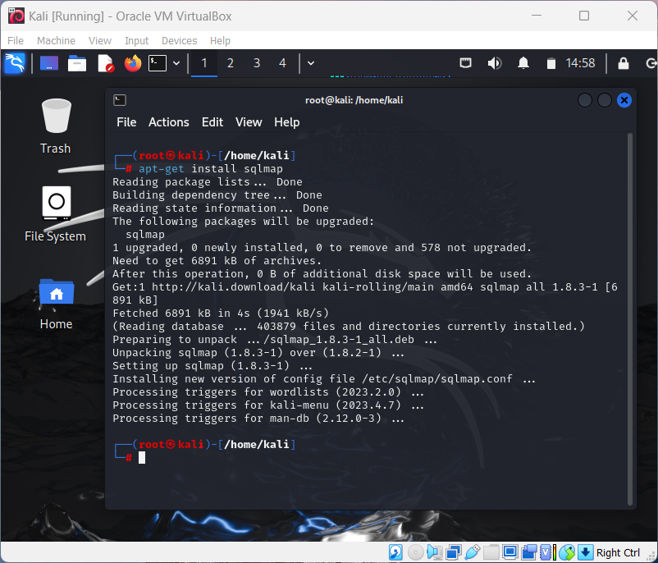

# Step -3 Identifying a Vulnerable Web Application:

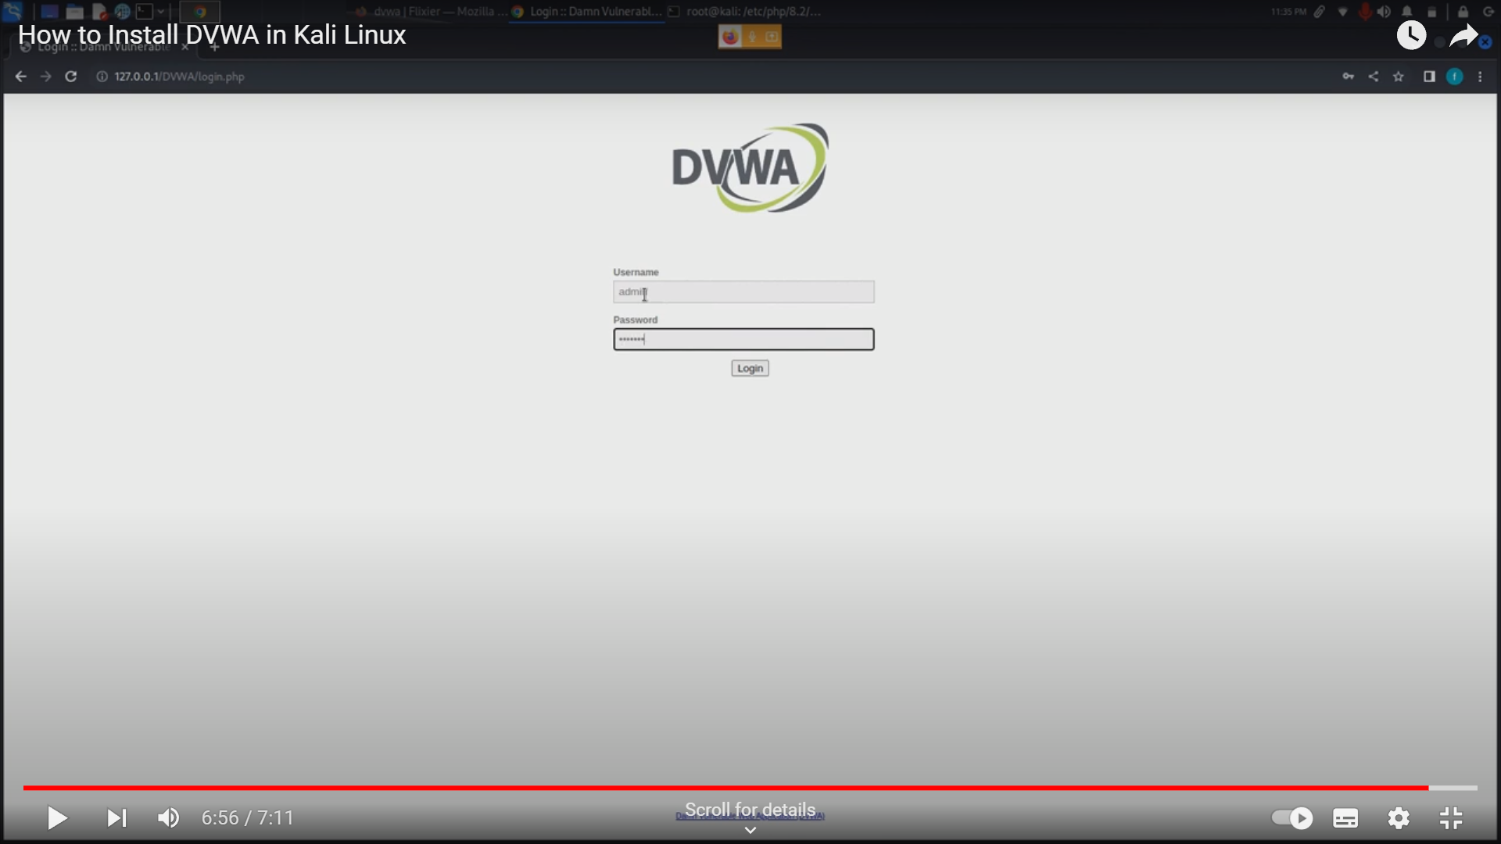

The above image is the login page of the vulnerable DVWA site.

Now open SQL injection tab and tap ‘OR 1=1 # then we get

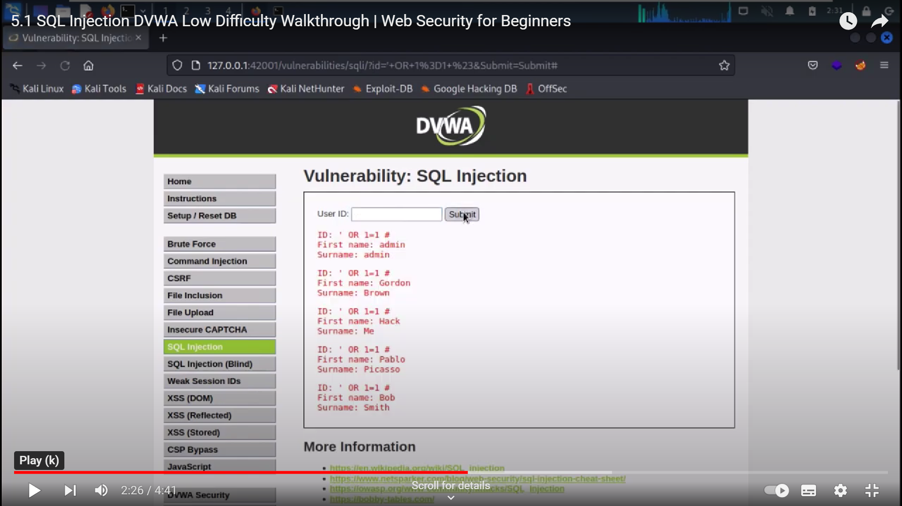

See this a vulnerability which is showing the user information and hence this is a vulnerable site.

# 

# Step -4 Performing a Basic SQL Injection Attack:

To perform this attack use command

sqlmap -u "http://target.com/page.php?id=1" --dbs , this will give the database of the target.



# Step -5 Documenting the Steps:

* sudo apt-get install sqlmap - To install sqlmap
* sqlmap -u "http://target.com/page.php?id=1" --dbs - to get database of target site